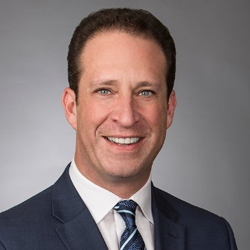

Mickey Silberman is the founder of and a Shareholder with Silberman Law PC. For more than 25 years Mickey has represented employers throughout the nation and in every industry regarding affirmative action, OFCCP, pay equity, and Diversity & Inclusion. He is a nationally recognized expert and public speaker in these areas. Mickey helps employers navigate the often tricky world of systemic EEO and he provides creative, practical and strategic counsel and legal representation.

