Biographies
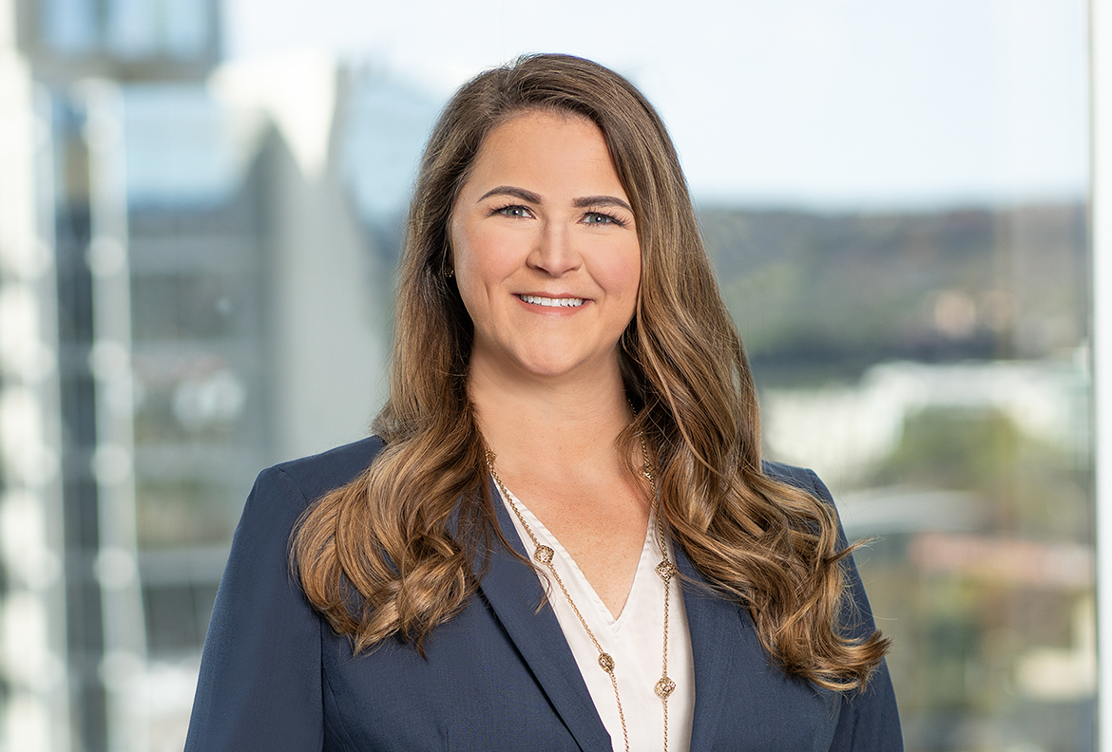 | Meredith Gregston  Senior Attorney  mgregston@HuntonAK.com  Austin  +1 512 542 5014
SERVICES  Industries  Energy  Financial Services  Real Estate Investment and Finance  Retail and Consumer Products  Telecommunications  Practices  Labor and Employment  Affirmative Action and OFCCP Compliance  Complex Employment Litigation  Diversity, Equity, and Inclusion Counseling  Pay Equity and Transparency  PeopleSmart  Wage and Hour Class Actions  EDUCATION  JD, Texas Tech University School of Law, 2013  BBA, University of Texas at Austin, McCombs School of Business, 2009  BAR ADMISSIONS  Texas | Meredith focuses her employment practice on affirmative action, pay equity, and diversity and inclusion, regularly assisting clients with a variety of employment matters, such as retaliation and discrimination claims, investigations, and day-to-day counseling.  Meredith provides advice and counseling on day-to-day employee-related and compliance matters, ranging from Family and Medical Leave Act (FMLA) and Americans with Disabilities Act (ADA) matters to termination best practices, restrictive covenants, and employment agreements, as well as advancements and changes in the pay equity space. She regularly assists clients through pay equity disputes and internal audits, and on global compliance with pay equity legislation. She also advises clients, including federal contractors, on affirmative action, legislative and regulatory changes affecting employment matters for federal contractors, and Office of Federal Contract Compliance Programs (OFCCP) compliance issues, developing affirmative action plans and representing companies during the audit process.  Meredith frequently partners with companies to analyze and develop diversity and inclusion initiatives, and to analyze compensation programs, to not only ensure they are in compliance with applicable law, but to help them achieve internal equity and other goals.  Meredith’s litigation practice includes all aspects of employment law, such as discrimination, harassment, retaliation, trade secrets, and wage and hour issues. She represents employers in state and federal courts, as well as proceedings before the Texas Workforce Commission, the Equal Employment Opportunity Commission (EEOC), and the OFCCP.  Meredith is actively involved in the National Industry Liaison Group (ILG), along with local ILGs, which assist federal contractors in obtaining education and networking with fellow federal contractors. Her role on the Board of the National ILG allows her to collaborate with OFCCP, EEOC, and other governmental agencies to address key issues faced by the contractor community and helps her stay current on regulatory changes and other agency developments.  Prior to joining the firm, Meredith was in-house counsel at a mutual fund where she addressed day-to-day employment law issues, managed employment matters in international offices, and helped develop employment policies. Her in-house experience, along with other prior secondments, gives her a unique perspective on how to balance business needs and objectives with various initiatives, and assists her in providing meaningful and cost-effective advice.  Relevant Experience  Represents government contractors and subcontractors in OFCCP audits regarding compliance with affirmative action laws and regulations.  Prepares affirmative action plans for government contractors and subcontractors, and counsels government contractors and subcontractors regarding all aspects of affirmative action obligations under federal law.  Counsels employers in developing and implementing meaningful and lawful diversity and inclusion initiatives.  Counsels employers in pay equity analyses and investigations, as well as other employment data analytics.  Represented a medical sales company in successfully negotiating a reduction in assessed penalties by the OFCCP from $10 million to $500,000.  Represented a healthcare company in successfully negotiating a reduction in assessed penalties by the OFCCP from $1.2 million to $200,000.  Represented a private investment firm focused on commercial real estate in the US and Europe in the employment aspects of the June 2020 acquisition and financing of a San Antonio-based property management firm with a portfolio including 30,000 apartment homes; the acquisition expanded the investment firm's integrated real estate platform of capital raising, acquisitions and property management, as well as its holdings in the “necessity housing” market.  Represented healthcare company in obtaining a complete victory and an approximately $108 million final award from nationwide insurer; the award included nearly $80 million in breach of contract damages (inclusive of interest) and more than $21 million in penalties against opposing party for violating Texas Prompt Payment laws, and also shifted attorneys’ fees and other costs onto opposing party and denied all counterclaims against healthcare client.  Represented regents of a large public university in an employment case involving claims of gender and disability discrimination, retaliation, and violations of the California Equal Pay Act. The jury found for the plaintiff on her disability discrimination and retaliation claims, but motions for judgment notwithstanding the verdict and for a new trial were successfully granted, with the jury verdict being vacated, resulting in judgment for the regents on all claims.  Memberships  National Industry Liaison Group, Board Member  North Texas Industry Liaison Group (NTILG)  San Antonio Industry Liaison Group (SAILG), Chair  The College of the State Bar of Texas  Travis County Women Lawyers Association  Austin Young Lawyers Association  Texas Young Lawyers Association  Austin Bar Association  American Bar Association  Courts  US District Court, Western District of Texas  US District Court, Southern District of Texas  US District Court, Northern District of Texas  Events  Presenter, Expert Panel – All things Compliance, Greater Houston ILG, May 21, 2024  Presenter, Post Harvard/UNC Decision - Doing DEI the Right Way , North Texas ILG, May 14, 2024  Presenter, 2024 (and Beyond) Legal Updates – What’s on the Horizon for Employers?, Arkansas ILG, March 27, 2024  Presenter, The New Scheduling Letter – What Contractors Should be Doing NOW to Prepare and What’s Happening in Audits, Arkansas ILG, March 27, 2024  Presenter, 2024 (and Beyond) Legal Updates – What’s on the Horizon for Employers?, Northwest ILG, March 22, 2024  Presenter, Current Status of Pay Equity and Transparency – What Companies Need to Know, Northwest ILG, March 22, 2024  Presenter, Navigating the Patchwork of Pay Equity and Transparency Laws - What Contractors Need to Know, Louisiana ILG, March 21, 2024  Presenter, Pay Equity, Transparency, and Disclosures – What Employers Need to Know, Colorado ILG, March 14, 2024  Presenter, 2023 and Beyond – Important Employment Law Developments, Hunton Andrews Kurth Webinar, March 13, 2024  Presenter, An (Un)Predictable Future – 2024 Employment Issues to Watch, March 13, 2024  Presenter, The Pay Equity Patchwork: Understanding the Laws and Best Practices in Analyzing Your Data, Baltimore Industry Liaison Group, February 13, 2024  Presenter, Doing Right the Right Way: Undertaking Lawful Race, Gender & Ethnicity Preferences in Employment, San Antonio Industry Liaison Group, January 17, 2024  Speaker, Is Your 2024 Policy in Compliance? Understanding the Legal Landscape of Pay Transparency and Pay Equity, New Jersey Industry Liaison Group, December 1, 2023  Speaker, Key Takeaways from OFCCP Developments and What Federal Contractors Need to Watch Out for in 2024, San Antonio Industry Liaison Group, November 15, 2023  Speaker, A Fireside Chat with the Director of Enforcement – Trends and Hot Topics, SWARM ILG Conference, October 19, 2023  Speaker, Questions from the Audience Answered and A View from the Office of Policy and Program Development, SWARM ILG Conference, October 19, 2023  Speaker, “Your Questions Answered/Breaking News,” SWARM ILG Conference, October 19, 2023  Speaker, Foundation Series Part 4: Compensation & OFCCP Audits, SWARM ILG Conference, October 17, 2023  Speaker, Recent Supreme Court Decision on Employment, SWARM ILG Conference, October 17, 2023  Presenter, Top Tips for Employers – Avoiding the Tangled Web of Termination Traps – Employer Mistakes and How to Reduce Risk, September 28, 2023  Moderator and Speaker, Advisory Council Expert Panel, NILG 2023 National Conference, August 4, 2023  Speaker, Termination Traps – Top 10 Employer Mistake and How to Avoid Them, NILG 2023 National Conference, August 3, 2023  Speaker, Navigating the OFCCP, State, and Local Pay Equity Landscape, NILG 2023 National Conference, August 2, 2023  Speaker, What You Need to Know About Compensation & Audits, NILG 2023 National Conference, August 1, 2023  Presenter, Top Tips for Employers – Is DEI Dead? What the Supreme Court’s Harvard/UNC Affirmative Action Decisions Mean For DEI Initiatives, July 12, 2023  Speaker, Pay Equity – It’s Still Making Headlines: What You Need to Know for Your Analysis, San Diego Industry Liaison Group (ILG), July 10, 2023  Speaker, How to Create Meaningful DEI Programs, Orange County Industry Liaison Group (ILG), May 31, 2023  Speaker, OFCCP Updates and Coast to Coast: Understanding the Pay Equity Landscape, Greater Houston Industry Liaison Group (ILG), May 17, 2023  Presenter, Navigating the OFCCP, State and Local Pay Equity Landscape, Michigan ILG, May 12, 2023  Presenter, Know Your Data! Best Practices for Performing a Compensation Analysis, April 18, 2023  Presenter, Navigating the Pay Equity and Transparency Landscape, Kansas City Industry Liaison Group, March 28, 2023  Presenter, Top Tips for Employers – Don’t Get Lost In the Dark - Navigating Pay Transparency and Pay Equity Laws, March 21, 2023  Speaker, Coast to Coast: The Pay Equity and Transparency Landscape, Western Arkansas Industry Liaison Group (WAILG), March 15, 2023  Speaker, Leveraging Your AA Data to Create Meaningful DEI Initiatives, Western Arkansas Industry Liaison Group (WAILG), March 15, 2023  Speaker, Presentation: Coast to Coast – An Overview of Pay Equity and Pay Transparency Laws, North Florida Industry Liaison Group, March 7, 2023  Speaker, Intersectionality of Race and Gender in Hiring and Pay Equity Analyses, Western Arkansas Human Resource Association, February 14, 2023  Presenter, Complying with the New Pay Transparency Laws, ACC Houston Half Day CLE Seminar: The Future of Work, January 5, 2023  Speaker, “Pay Equity: Coast to Coast,” San Antonio Industry Liaison Group, November 16, 2022  Speaker, “Intersectionality of Race and Gender in Hiring and Pay Equity Analyses,” Philadelphia Industry Liaison Group, October 18, 2022  Speaker, “Follow the Money: Handling Hiring Claims in OFCCP Audits,” National Industry Liaison Group National Conference, July 27, 2022  Speaker, “Intersectionality of Race and Gender in Hiring and Pay Equity Analyses,” National Industry Liaison Group National Conference, July 26, 2022  Speaker, “Leveraging Your OFCCP Compliance Efforts to Support D&I Initiatives,” North Texas Industry Liaison Group, November 16, 2021  Speaker, “Don't Forget: Diversity and Inclusion Starts with Pay Equity,” NILG 2021 National Conference, August 3, 2021  Speaker, “Foundations Part 4: Comp and Audits,” NILG 2021 National Conference, August 3, 2021  Speaker, ”Leveraging Your OFCCP Compliance Efforts to Support D&I Initiatives,” NILG 2021 National Conference, August 2, 2021  Speaker, “Steps for Getting Through OFCCP Audits with Maximum Success,” Baltimore ILG Webinar, February 9, 2021  Speaker, “Termination Traps: Top Ten Mistakes Employers Make When Terminating Employees and How to Avoid Them,” BCGi Summit, Webinar, October 28, 2020  Speaker, “Steps for Getting Through OFCCP Audits with Maximum Success,” San Antonio Industry Liaison Group, Webinar, October 21, 2020  Speaker, “Since We Are Talking About Pay…Leveraging Your OFCCP Compliance Activities to Learn More About Your Pay Equity Situation,” Industry Liaison Group National Conference, August 1, 2019  Speaker, “Affirmative Action Plans: Compliance Plus Collaboration,” Industry Liaison Group National Conference, July 31, 2019  Speaker, “Leveraging Your OFCCP Compliance Efforts,” North Texas Industry Liaison Group, May 2019  Speaker, “Leveraging Your OFCCP Compliance Efforts” Greater Houston Area Industry Liaison Group, April 2019  Speaker, “Leveraging Your OFCCP Compliance Efforts,” San Antonio Industry Liaison Group, February 2019  Speaker, “Pay Equity – Navigating the Issues,” North Texas Industry Liaison Group, November 15, 2018  Speaker, “Navigating Compliance with Complex Recruiting Strategies,” National Industry Liaison Group, August 2, 2018  Speaker, “Navigating Compliance with Complex Recruiting Strategies,” Arkansas Industry Liaison Group, Little Rock, October 25, 2017  Speaker, “The Gender Gap was not Built in a Day and Neither are the Solutions – A Holistic Approach to Pay,” Arkansas Industry Liaison Group, Little Rock, October 25, 2017  Speaker, “Gender Pay Equity: What’s Working and What's Not,” Texas 15th Annual Employment Law Update, Austin, October 20, 2017  Speaker, “Complying With OFCCP Guidelines for Hiring People With Disabilities,” Lorman Webinar, Austin, August 31, 2017  Speaker, “The Gender Gap Was Not Built in a Day and Neither are the Solutions – A Holistic Approach to Pay,” 2017 National Industry Liaison Group Conference, San Antonio, August 2, 2017  Speaker, “Understanding the Fair Pay and Safe Workplaces Final Rule,” Austin Industry Liaison Group, Austin, November 8, 2016  Speaker, “Proper Dispositioning of Applicants and Its Importance in Defending Against Discrimination in OFCCP Audits,” San Antonio Industry Liaison Group, Austin, August 18, 2016  Media Mentions  Quoted, Recruiter’s Lawsuit Challenges Diversity Program on Religious Grounds, SHRM, August 1, 2023  Quoted, What Won’t Change Under the Biden Administration, SHRM, January 4, 2021  Publications  Co-author, Federal Court Rules EEO-1 Reports Not FOIA-Exempt, The National Law Review, January 11, 2024  ESG Hot Topics, Fall 2023  Co-author, 10 common termination traps — and how to avoid them, HR Dive, November 22, 2023  Co-author, DEI programs are under fire. Is yours the next target?, HR Dive, September 19, 2023  Co-author, Racial Stereotypes’ Use May Doom Some Employers’ DEI Initiatives, Bloomberg Law, September 13, 2023  Co-author, Woke: The New Four-Letter Word, Employee Relations Law Journal, Winter 2023  Co-author, Words matter — Can your DEI policies be evidence of (reverse) discrimination claims?, Reuters Legal News, July 11, 2023  Co-author, The Differing Court Approaches To Pay Equity Questions, Law360, July 5, 2023  Co-author, US Department of Labor Issues Final Rule Implementing Minimum Wage Increase for Federal Contractors, Pratt’s Government Contracting Law Report, February 2022  Co-author, OFCCP Continues Issuing Directives: What We've Seen and the Newest Developments, OFCCP Digest, Volume 8, Issue 10, 2018  Blog Posts  Co-author, EEOC and OFCCP Updates – Upcoming Deadlines, Revised Benchmarks and New Race Categories, Hunton Employment & Labor Perspectives, April 11, 2024  Co-author, Final Rule Requires Project Labor Agreements for Federal Construction Contractors, Hunton Employment & Labor Perspectives, January 12, 2024  Co-author, Federal Court Rules EEO-1 Reports Not FOIA-Exempt, Hunton Employment & Labor Perspectives, January 11, 2024  Co-author, USDOL Finalizes Right of First Refusal Regulation for Federal Contractors, Hunton Employment & Labor Perspectives, January 3, 2024  Co-author, Federal Contractor Minimum Wage in Flux, Hunton Employment & Labor Perspectives, October 9, 2023  Co-author, New OFCCP Scheduling Letter and Itemized Listing Increases Burden on Federal Contractors, Hunton Employment & Labor Perspectives, September 6, 2023  Co-author, OFCCP Publishes Final Rule on Pre-Determination Requirements and Conciliation, Hunton Employment & Labor Perspectives, August 22, 2023  Co-author, TikTok “Bytes” the Dust for Federal Contractors and Other Important Updates, Hunton Employment & Labor Perspectives, August 11, 2023  Co-author, Pay Equity Claims Are on the Rise – How Are Courts Interpreting the Differences in State and Federal Laws?, Hunton Employment & Labor Perspectives, June 8, 2023  Co-author, Pay Equity – A Patchwork Legal Landscape, Hunton Employment & Labor Perspectives, May 17, 2023  Co-author, Pay Disclosure and Transparency Efforts Across the Country, Hunton Employment & Labor Perspectives, April 10, 2023  Co-author, OFCCP Makes Headlines – What’s Happening at the OFCCP?, Hunton Employment & Labor Perspectives, April 4, 2023  Co-author, States Push Pay Reporting Requirements in Effort to Ensure Pay Equity, Hunton Employment & Labor Perspectives, March 10, 2023  Co-author, New Year – New Hurdles, Hunton Employment & Labor Perspectives, February 3, 2023

